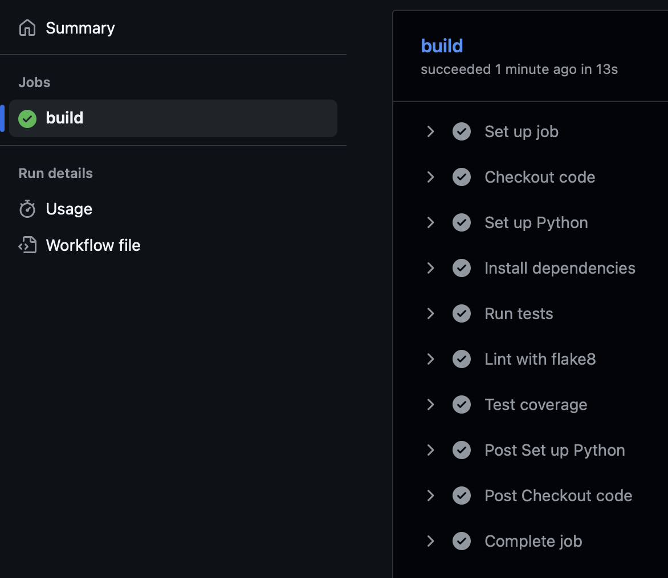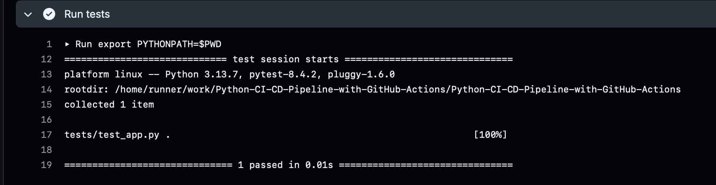https://github.com/asafked121/Python-CI-CD-Pipeline-with-GitHub-Actions